**PROJECT TITLE: AIR QUALITY MONITORING**

**NAME :** ASWIN B

**REG NO** : 953021106010

**COLLEGE CODE :** 9530

**COLLEGE NAME :** ST.MOTHER THERESA ENGINEERING COLLEGE

**PROBLEM STATEMENT :**

It refers to the contamination of the atmosphere by harmful chemicals or biological materials. It may cause diseases, allergies, and severe health problems in humans and other living organisms and may damage the natural environment

**BLOCK DIAGRAM :**

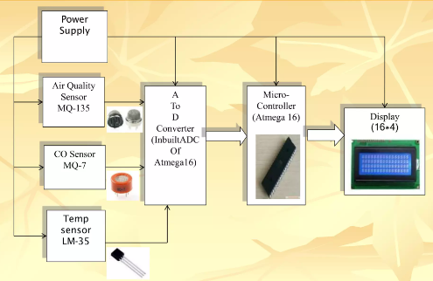

**INNOVATION :**

Air pollution is a growing concern worldwide. Our proposed IoT-based air monitoring system offers enhanced accuracy and real-time monitoring capabilities leading to better-informed decisions and actions tomitigate the negative impact of polluted air.

**WORKING EXPLANATION:**

The MQ135 sensor can sense NH3, NOx, alcohol, Benzene, smoke, CO2 and some other gases, so it is perfect gas sensor for our Air Quality Monitoring Project. When we will connect it to Arduino then it will sense the gases, and we will get the Pollution level in PPM (parts per million). MQ135 gas sensor gives the output in form of voltage levels and we need to convert it into PPM. So for converting the output in PPM, here we have used a library for MQ135 sensor, it is explained in detail in “Code Explanation” section below.

Sensor was giving us value of 90 when there was no gas near it and the safe level of air quality is 350 PPM and it should not exceed 1000 PPM. When it exceeds the limit of 1000 PPM, then it starts cause Headaches, sleepiness and stagnant, stale, stuffy air and if exceeds

When the value will be less than 1000 PPM, then the LCD and webpage will display “Fresh Air”. Whenever the value will increase 1000 PPM, then the buzzer will start beeping and the LCD and webpage will display “Poor Air, Open Windows”. If it will increase 2000 then the buzzer will keep beeping and the LCD and webpage will display “Danger! Move to fresh Air”.

**REQUIRED COMPONENTS :**

|  |  |  |
| --- | --- | --- |
| **S.NO** | **COMPONENTS NAME** | **QUANTITY** |
|  | MQ135 Gas sensor | 1 |
|  | Wi-Fi module ESP8266 | 1 |
|  | 16X2 LCD Display | 1 |
|  | Breadboard | 1 |
|  | 10K potentiometer | 1 |
|  | 1K ohm resistors | 1 |
|  | Arduino Uno | 1 |
|  | 220 ohm resistor | 1 |
|  | Buzzer | 1 |
| 10. | Connecting Jumper Wires | 1 |

**SOFTWARE :**

* ARDUINO

Arduino is an open-source electronics platform based on easy-to-use hardware and software. Arduino boards are able to read inputs - light on a sensor, a finger on a button, or a Twitter message - and turn it into an output - activating a motor, turning on an LED, publishing something online.